Preparing for R workshop

Below are some instructions for installing R and brief descriptions of files that we’ll be using in workshop exercises. Please install both R and RStudio on your laptops, and also download the .csv files for the exercises by 8 a.m. on Monday, June 19.

The course will be held in St. Edmund’s 205 at St. Michael’s College from 10 a.m. – 2 p.m. with a break for lunch.

Please e-mail me at [jory.hecht@uvm.edu](mailto:jory.hecht@uvm.edu) if you have any questions before the workshop!

# R installation instructions:

**First, download R version 3.4.0:**

Here is a good link for Windows users:

<https://cran.r-project.org/bin/windows/base/>

For Mac users:

<https://cran.r-project.org/bin/macosx/>

**Then, download RStudio Desktop:**

Download [RStudio Desktop](https://www.rstudio.com/products/rstudio/download2/) with a free open source license (it will also work on your laptop). This R workspace is much more user-friendly than using just -the main console. This site has installers for both Windows and Mac users.

Open RStudio to make sure it works.

Without any open R scripts, it should look like this:

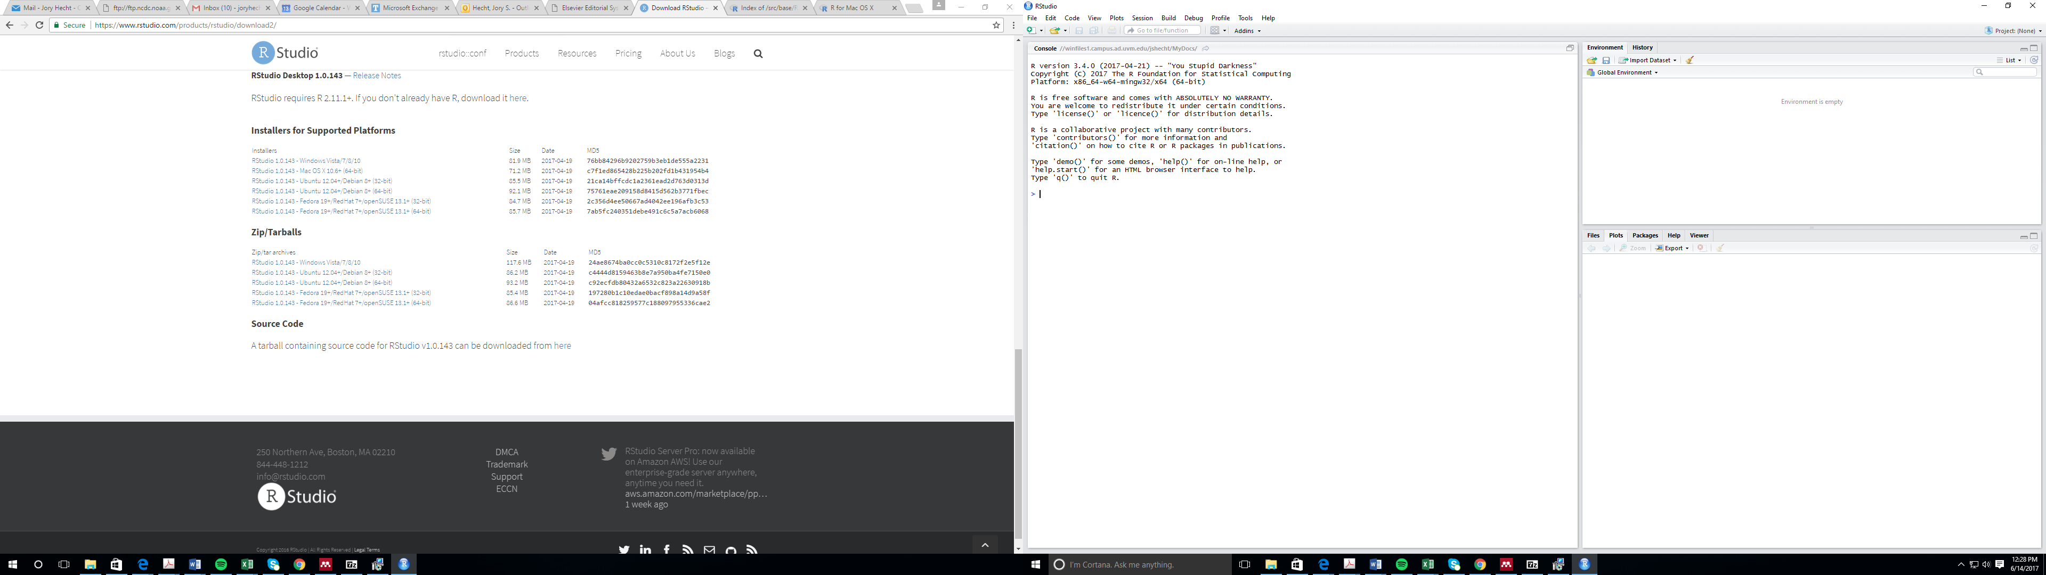

# Data for exercises

I am also attaching some hydrometeorological data, which we will use in exercises, in a zipped file. I will provide a brief overview of these files, including basic hydrometeorological concepts associated with them (e.g., what exactly is discharge?), during the workshop. However, the primary focus of the workshop will be learning about R. These files can also be found on my Github site at:

<https://github.com/jshecht/R_Workshop_BREE_Interns>

|  |  |
| --- | --- |
| **File name** | **Brief description** |
| QDaily_Swanton_USGS_04294000.csv | Daily mean discharge measured in cubic feet per second (cfs) at the United States Geological Survey station on the Missisquoi River at Swanton, VT.  (Mean discharge on each day from March 1, 1990 to current) |
| QPeak_Swanton_USGS_04294000.csv | Annual peak instantaneous discharge measured at the United States Geological Survey station in Swanton on the Missisquoi River at Swanton, VT during the 1991-2016 *water years*.  (Note that we are using the United States Geological Survey’s October 1 – September 30 water year when identifying annual peak instantaneous discharges. The 1991 water year begins on Oct 1, 1990.) |
| PDaily_Enosburg.csv | Daily precipitation compiled from two weather stations (NCDC 991461, 991807) in Enosburg, VT from Oct 1, 1990 – September 30, 2016. Monthly means used to fill missing data (<1% days). |